# Advanced Firefox Features

Contents

Advanced Firefox Features 1

Create a Bookmark 2

Backup Bookmarks 4

Importing Bookmarks 10

FACT SHEET 13

**For further assistance or questions about this document please contact the IT Service Desk @ 306-787-5000.**

## Create a Bookmark

Open the desired URL by copying and pasting a URL from another source~~.~~

Click on the address bar and paste in the URL. Enter to proceed to the Web Page. You may also click on the address bar and enter the URL directly by typing the address into the address bar space and hit enter to proceed to the Web page

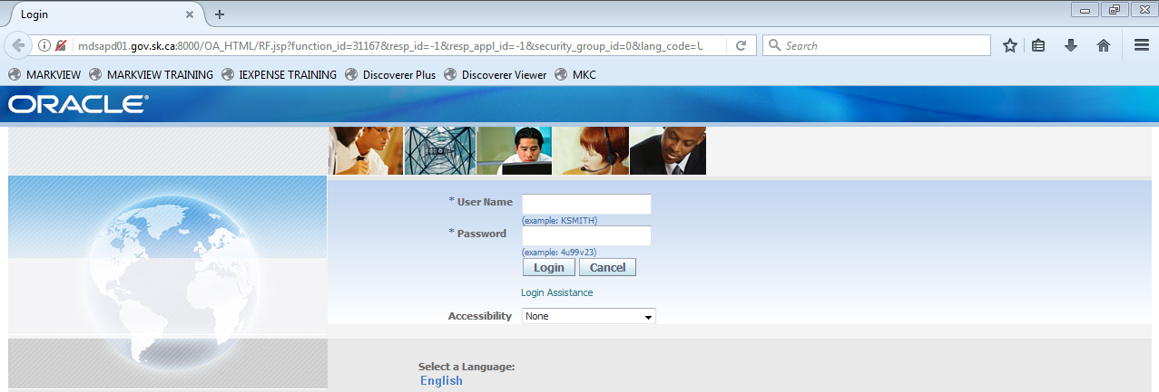

You can now save this URL as a bookmark by clicking on the “star” beside the address bar or by using the Ctrl+D key combination and you will see the following screen.

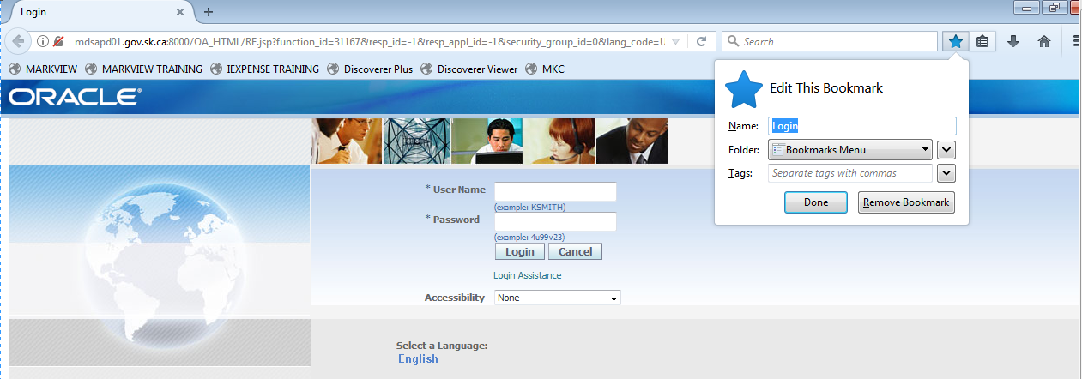

Here you have options on how you want to organize your Bookmark. This is user preference. Once you have made your updates, click Done.

You can also reorganize your bookmarks by clicking on “Bookmarks/Show all Bookmarks” and you will see the following screen.

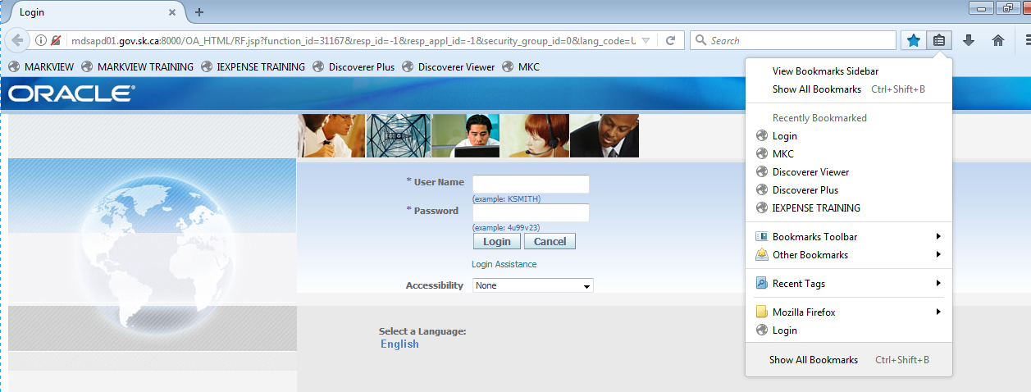

***\*\*\*\* PLEASE note that any Bookmarks will be wiped out with each release of Virtual Firefox for MIDAS. The Backup and Import steps outlined below, need to be executed prior to any new releases to Firefox. These releases will be communicated ahead of time and need to be your trigger to complete a backup of your bookmarks. Once the release of Virtual Firefox for MIDAS has been completed you will need to execute the Import steps to restore your previous bookmarks into your new release of Firefox\*\*\*\*\****

## Backup Bookmarks

Menu, click Bookmarks/Show all Bookmarks (or Ctrl+Shift+B) and a new sub window opens. Click Import and Backup button and a drop list will appear. Select Backup.

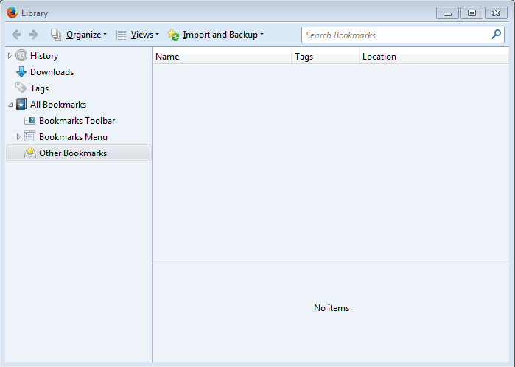

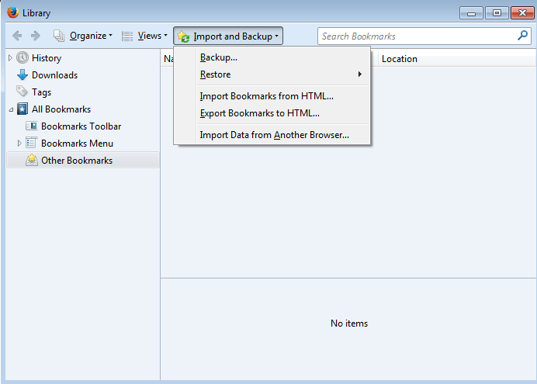

Click on the icon (Your username on GOS #)

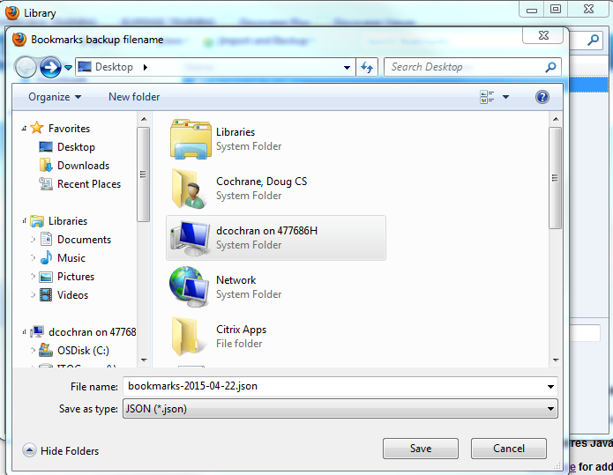

Click on your H Drive mapping and click open

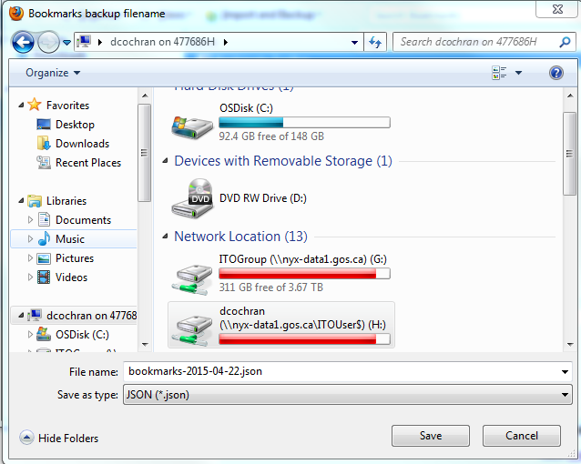

You can simply click save here or you have the option to create a subfolder which requires you to click the New Folder button, you can now type the folder name that you want to use and hit enter.

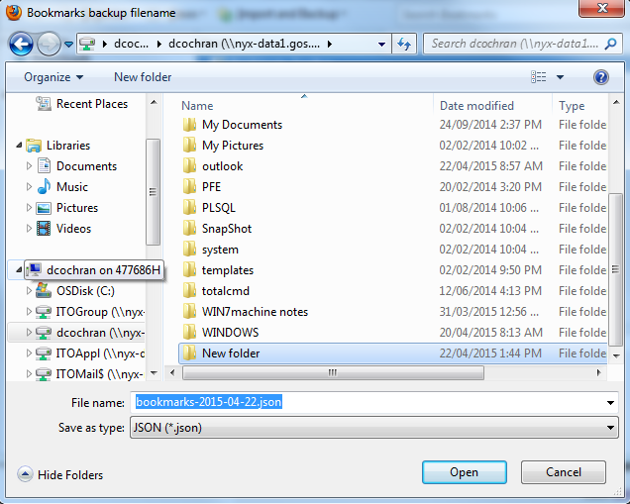

Your screen will update with the new folder name and presents you with the open option. You need to click the open button to Navigate into your new folder.

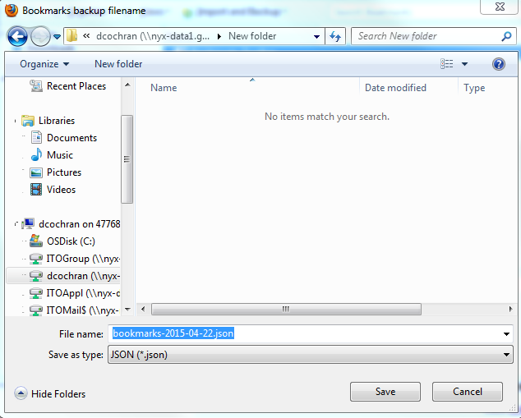

Suggest that you leave the File Name and Save as type as they are, do not change them. Now click the Save button, your Bookmarks are now backed up to your H drive,

You will be returned to the previous screen. Click on the X to close this window.

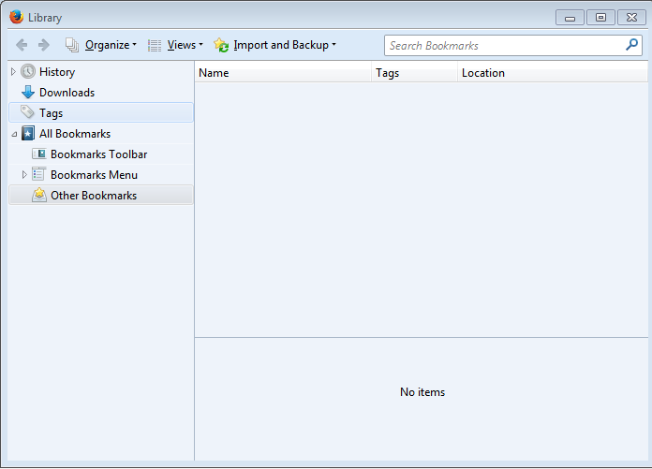

## Importing Bookmarks

Menu, click Bookmarks/Show all Bookmarks (or Ctrl+Shift+B) and a new sub window opens. Click Import and Backup button and a drop list will appear. Select Restore.

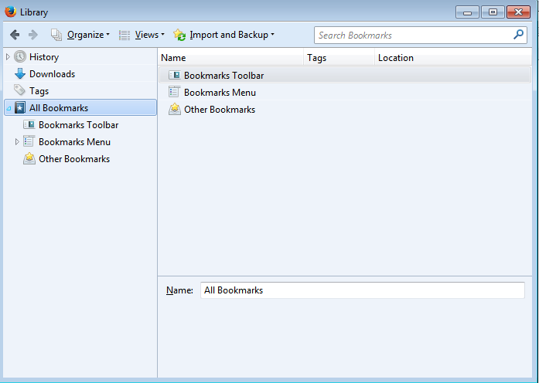

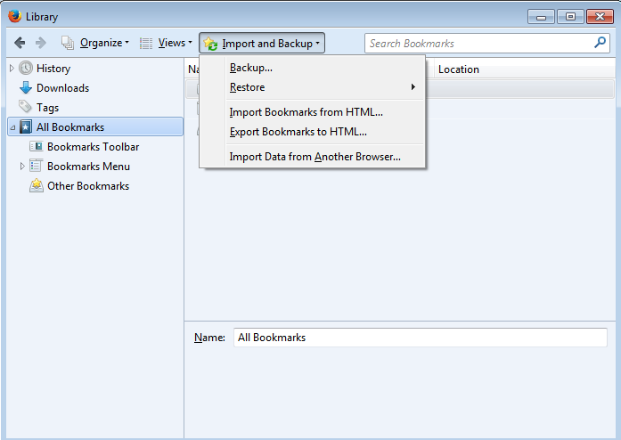

When you click Restore it extends the menu option and presents the filenames of previous backups completed, click on dated version you’d like to restore or you can select Choose File to navigate to a previously saved JSON file that you made on the network or desktop (see Backup Bookmarks).

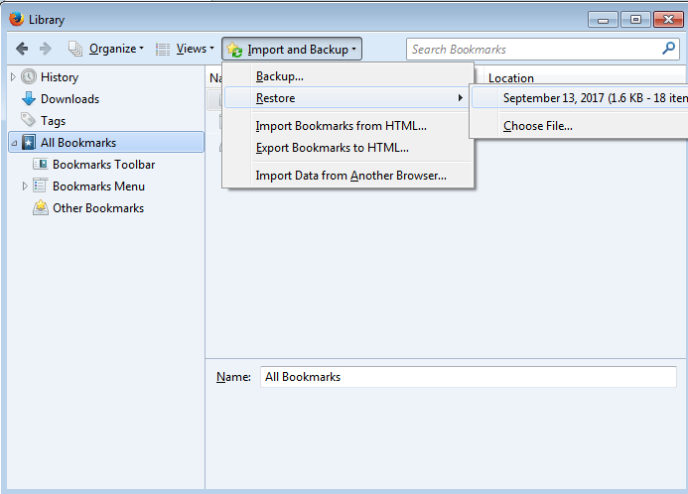

Click Ok to restore or cancel to abort the restore activity

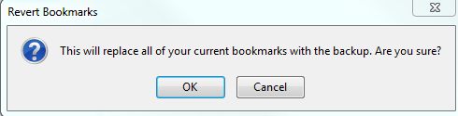

Click the x to close this window and you will return to the original screen



## FACT SHEET

* **Default Browser:** Firefox is not set to be your Default browser as that may have adverse effects on other applications that you have.
* **Browsing:** Firefox uses tabbed browsing by default. The forms navigator and the forms windows within the MIDAS application will open in a new tab. This is intended functionality and is not a bug. These windows will appear on your Windows task bar.

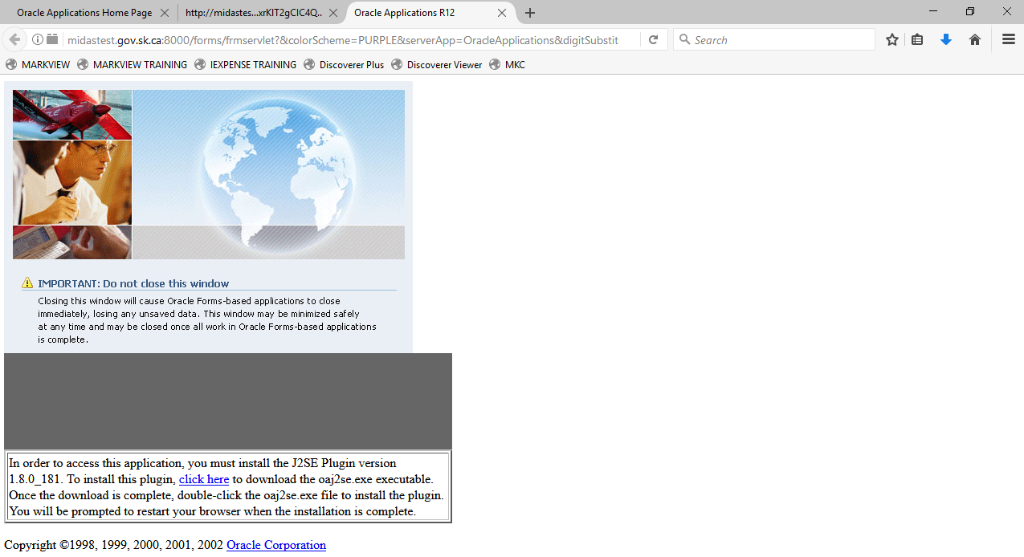



* **Session lock due to inactivity**: When your MIDAS session locks due to inactivity, a new window opens, but flashes at the bottom in the Windows task Bar.  The window is called “Login – Mozilla Firefox”. Also, when you enter your password it may take you back to a Window other than the MIDAS window that had locked.  It is likely to take you to the Navigator screen in MIDAS.  You then have to figure out which tab on the firefox browser of your screen you need to click on to find your way back to where you were when you timed out.
* **Bookmark management:** Users are asked to follow the steps and guidelines in this document. If users deviate from the instructions and save their bookmarks with different names, into different locations, it will make it difficult for the IT Service Desk to track down what you may have done and successfully restore that backup.
* **Multiple sessions in MIDAS:** You can continue to sign onto different regions (such as Discoverer) within Firefox by opening a separate tab as outlined previously.
* **Issues caused by a new Virtual Firefox for MIDAS release:** When new versions of the Virtual Firefox for MIDAS application are released (down the road) there may be rare instances where a client does not receive the new release and the process removes their previous version icon. The newest Virtual Firefox for MIDAS can be found under the Start Menu🡪GOS Applications. You can create a shortcut on your desktop by right clicking on Midas icon and dragging it to your desktop and when asked choose “Create shortcuts here”

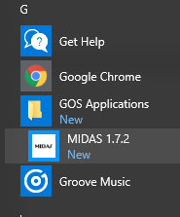

* It is also possible that clients may receive an error message when they click on their MIDAS icon. If an error message occurs, you can remove the desktop shortcut and try the above step to recreate your desktop shortcut. If that still doesn’t work, you will need to call the IT Service Desk at 306-787-5000 for assistance.

**For further assistance or questions about this document please contact the IT Service Desk @ 306-787-5000.**