# MIDAS – Initial Login for Users

To access MIDAS locate the MIDAS Firefox Browser icon on your desktop:

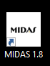

If the icon is not found on your desktop, open the start menu and then look under “GOS Applications”. From here, click on the MIDAS icon.

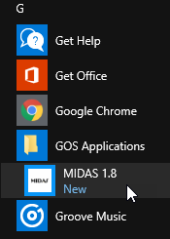

* To create a shortcut on your desktop right click the MIDAS icon and select the options “Send to”>“Desktop (create shortcut)”. NOTE: Shortcuts do not get updated when new versions are released and pushed to the user. The shortcut will have to be recreated upon each new release.

**Signing into MIDAS**

The Firefox application will load and prompt you with the following MIDAS login screen. Enter your user name and password then press the “Login” button.

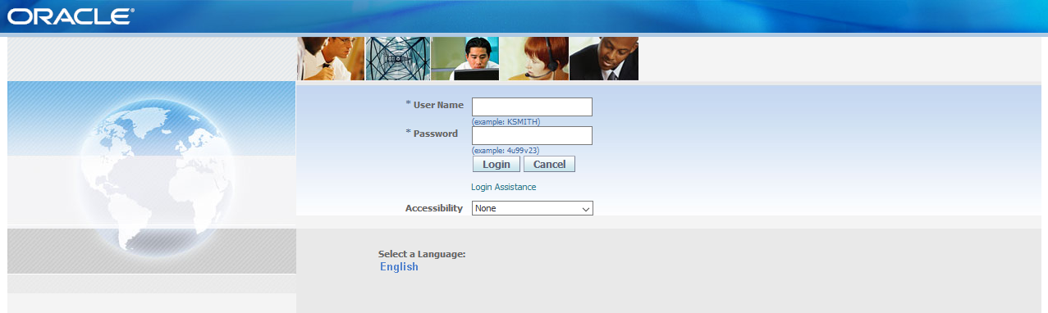

If you are a first time user or in some cases due to system updates you may receive a Java pop-up similar to this:

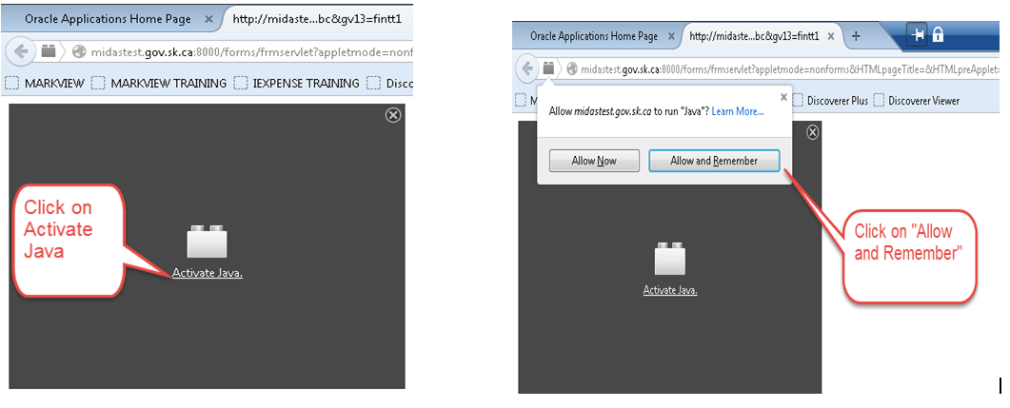

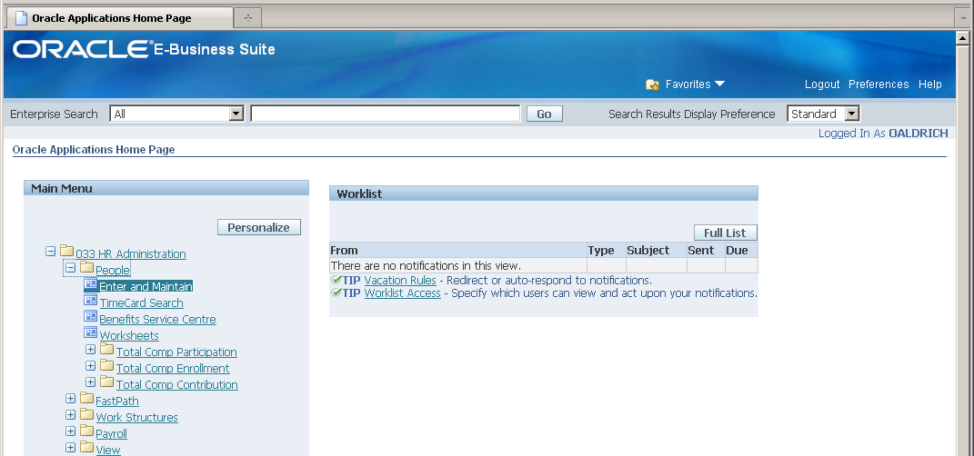

Once logged in a MIDAS navigation page similar to the one shown above should appear. Click on one of the menu items on the left of the screen (the menu items will appear different depending on the responsibility you are accessing).

After an option is selected from the navigation page a new window *may* appear:

Click the “I Accept” box then click on Run

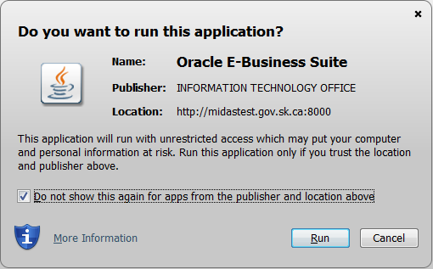

Important – Future visits to the MIDAS Application:

For future sign-ons to MIDAS you may receive the following pop-up. This is an issue that is being actively worked on. When fixed, the pop-up will no longer appear.

