**MIDAS Home Page:**

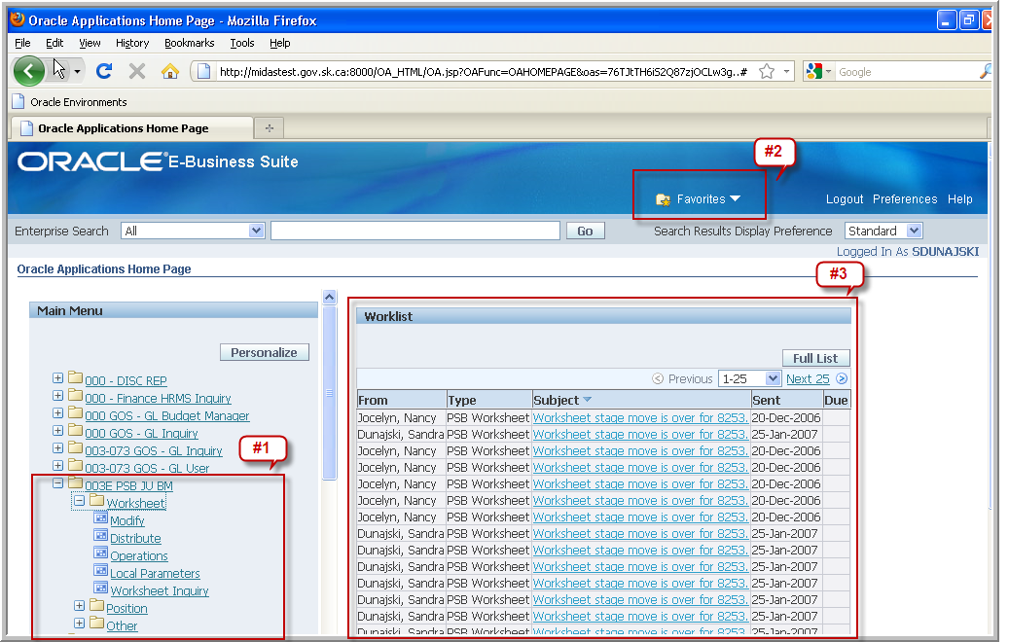

1. Main Menu – Form paths are organized in folders by responsibility and functions based on user access. Users can double click on folders to expand / collapse responsibility functions so they can launch the form to perform the desired action.
2. Manage Favorites – Favorites are now located at the top of the Oracle Application Home Page and are accessed through the use of a drop down menu. If existing favorites were created, you will be able to select them from the dropdown menu. To create / manage favorites select Manage Favorites in the dropdown menu and the Customize Favorites form will open.
3. Worklist – this is new area located on Oracle Applications Home Page in which you can view recent MIDAS system generated notifications.

**How to Address Items in Your Worklist:**

Items in your worklist can be cleared by one of two ways; individually or in groups.

**Worklist Clearing Option # 1 - Individually:**

Click on the worklist notification under “Subject”:

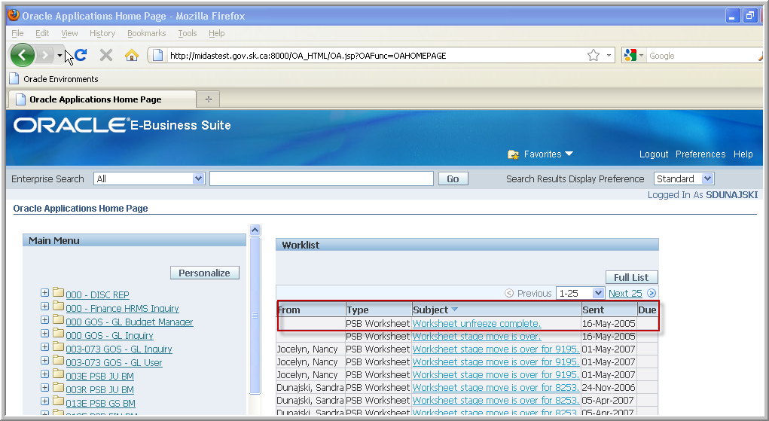

You will be taken to the notification information page

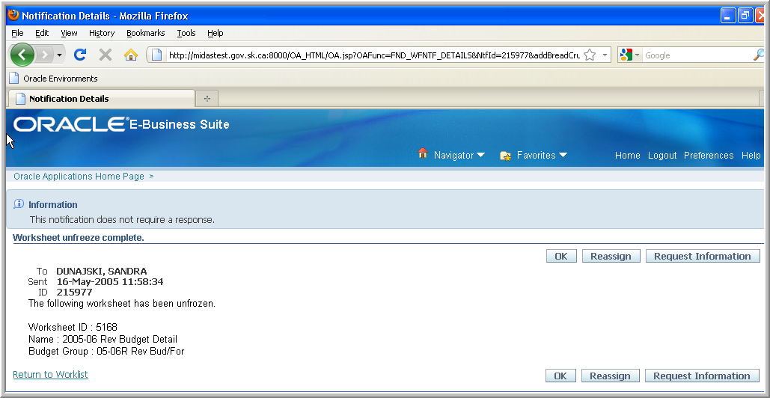

Click on the “OK” button.

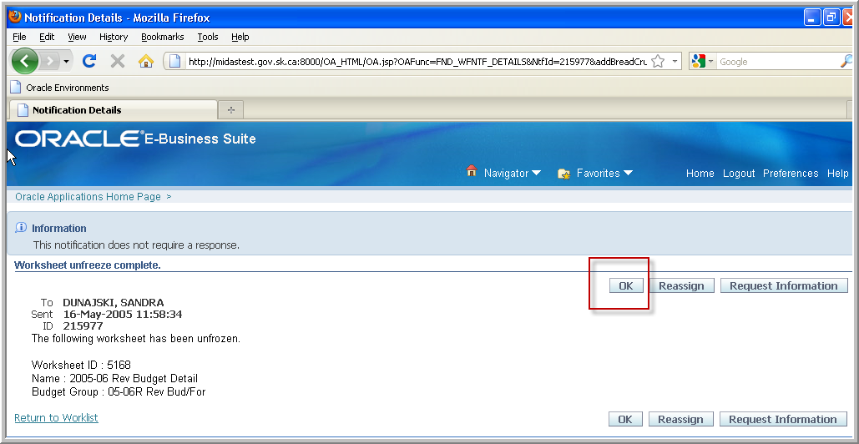

It will return you back to the home page and your notification will no longer appear.

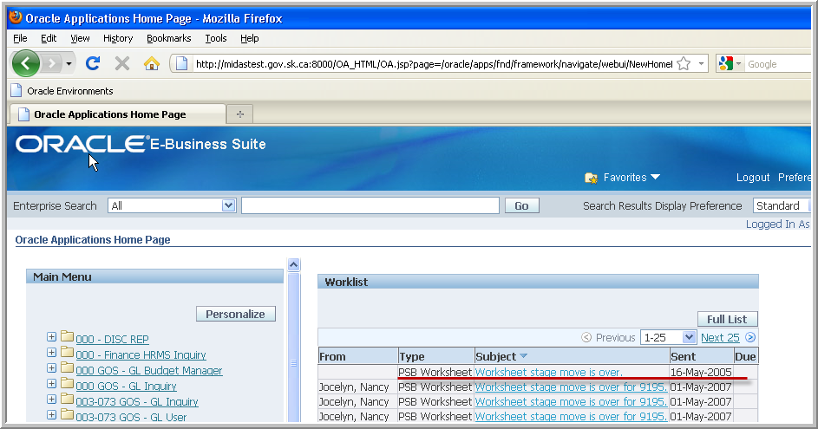

**Worklist Clearing Option # 2 in Groups.**

Click on the “Full List” button.

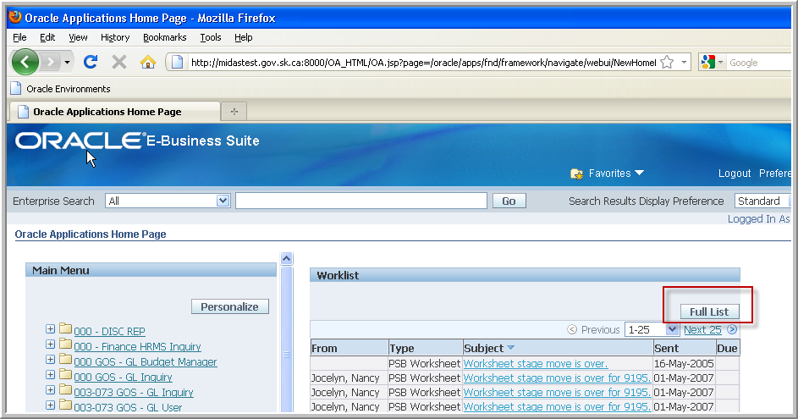

Click on the “Select All” (this will select all notification displayed on the page).

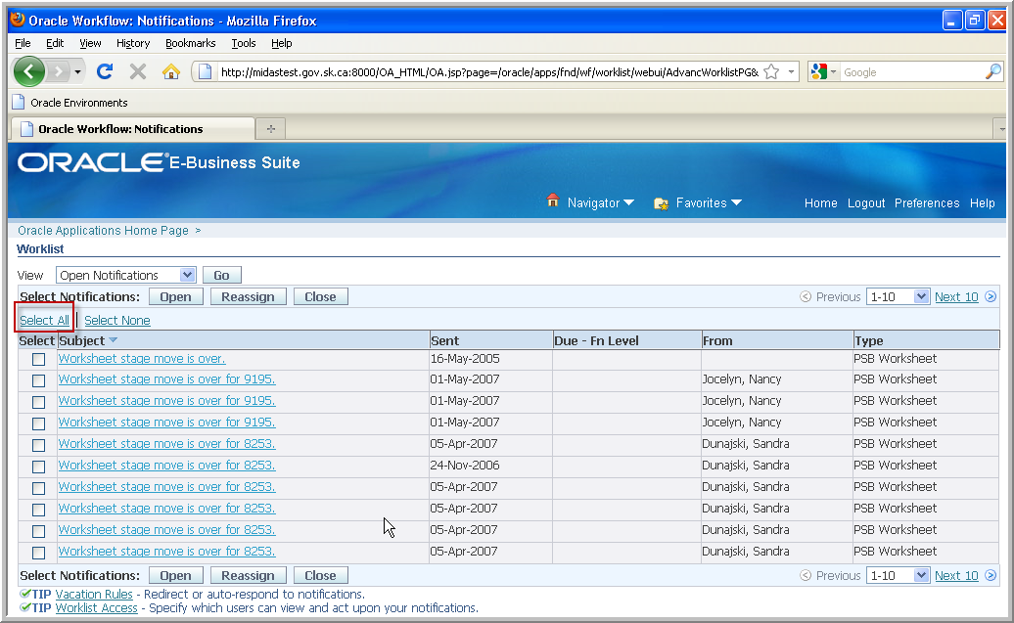

Click on the “Close” button – this will close all notifications selected and take you to a warning page.

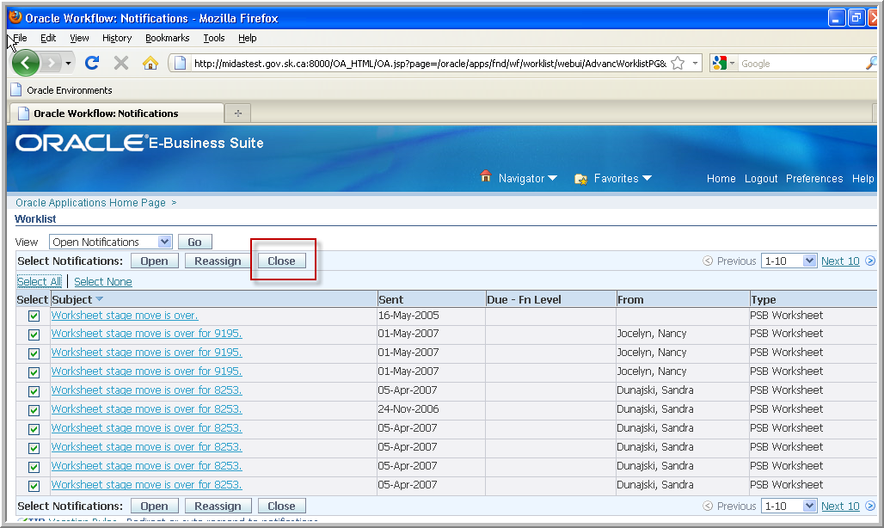

From the warning page click on “Apply”.

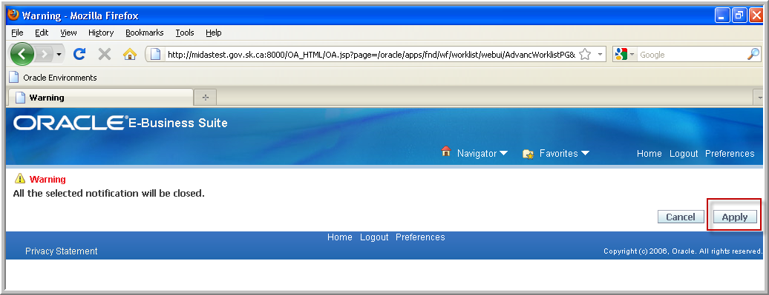

After you click on the “Apply” button your next ten notifications will appear. You can continue to close the next ten by selecting the “Select All” and follow through as you did above, or you can return to the home page by clicking on “Home”.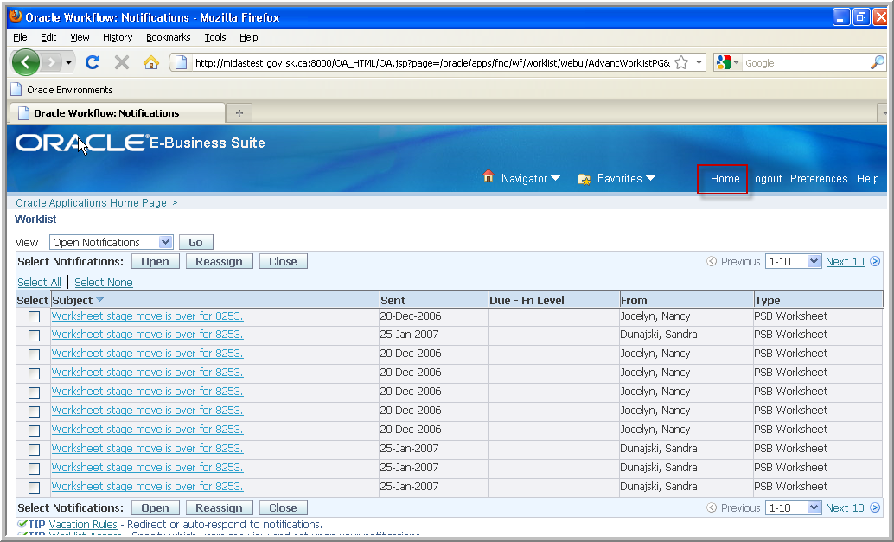

**How to Manage Favorites:**

Click on the Favorites drop down arrow and select “Manage Favorites”

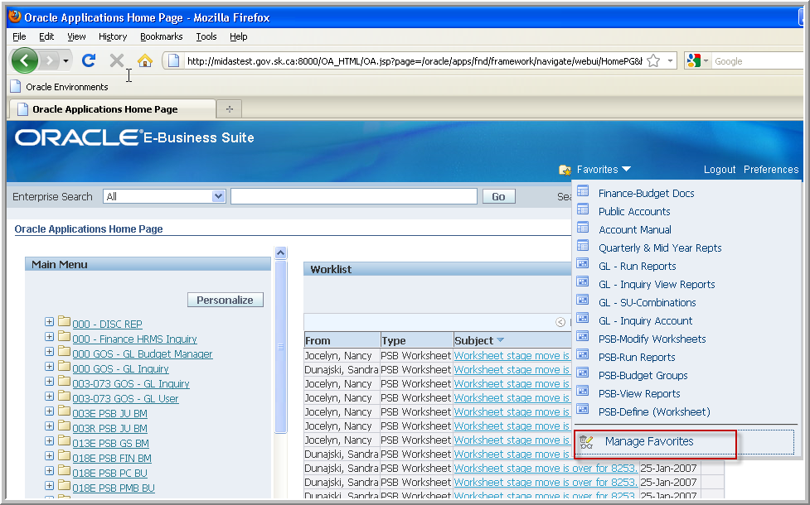

Click on the drop down arrow and select a Responsibility

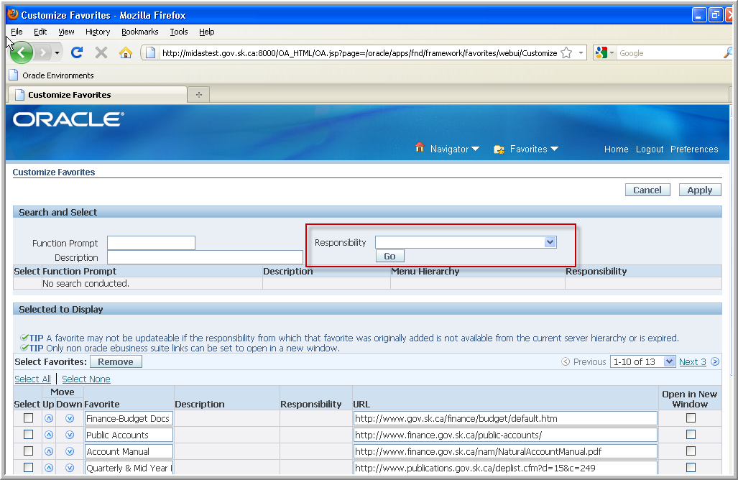

A list of Functions will appear in your right column. From the list of Functions, select the desired Function or Functions and click “Add”.

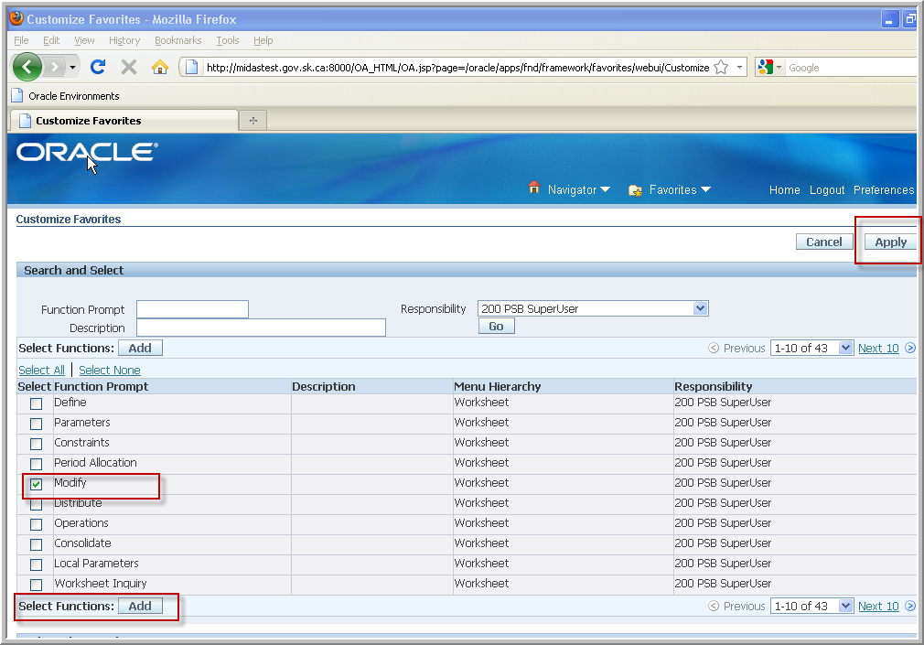

* To change the name of or add specific detail to the function you have just added, scroll down the page to “Selected to Display”

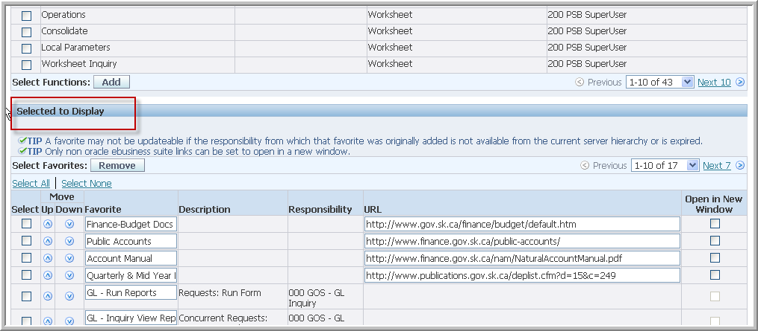

Find the item you just added.

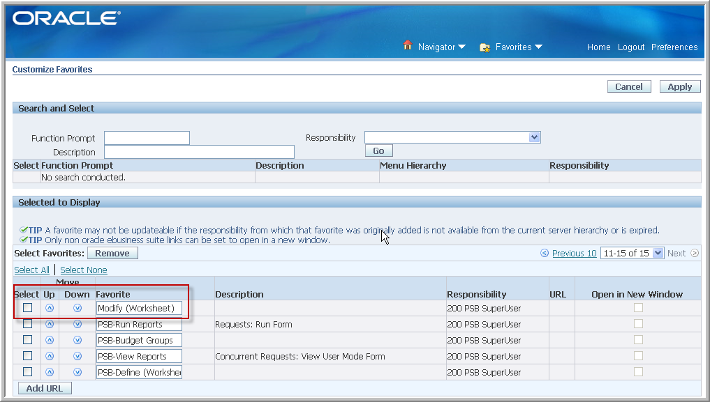

Edit the Favorite box then click “Apply”. This again will take you back to the Home page.

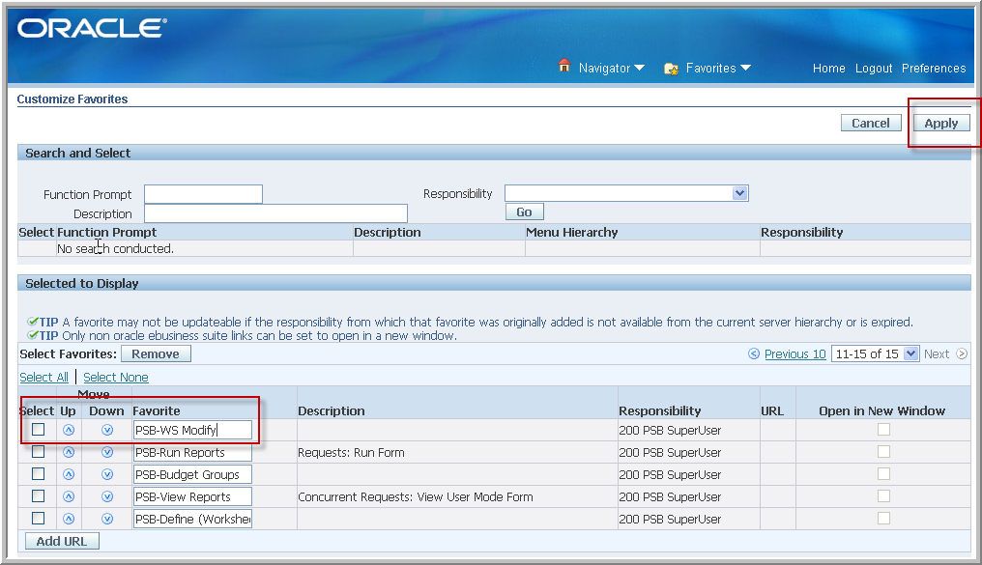

Click on the Favorites dropdown arrow to see your update.

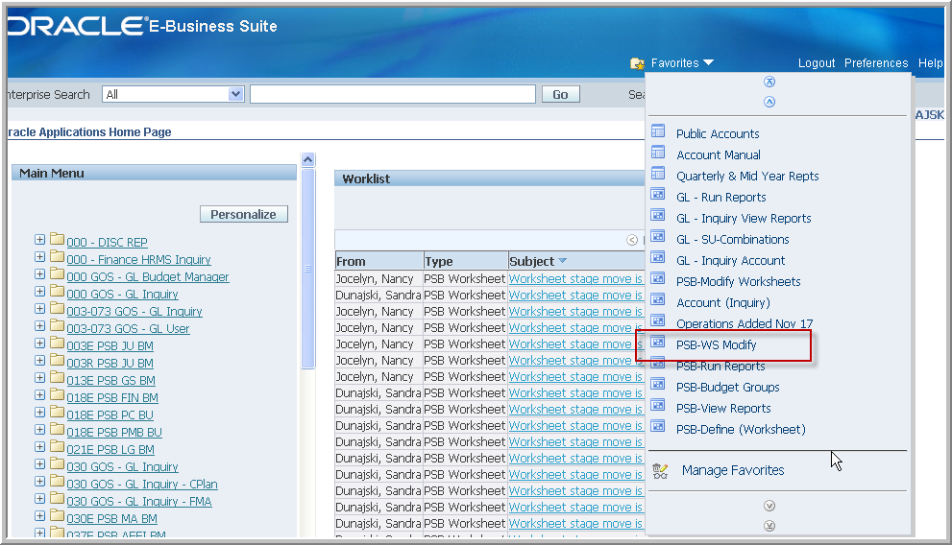

For further information or assistance please contact one of the MIDAS Help Desks:

**MIDAS Financials Help Desk**

**Ministry of Finance**

**Phone: (306) 798-9999**

**Email: FI GRP - MHD (finmhd@gov.sk.ca)**

**MIDAS HR/PAY Help Desk**

**Public Service Commission**

**Email: PSC MIDAS-MHD (PSCMIDAS-MHD@gov.sk.ca)**