**MIDAS – Login Assistance**

Users can use the automated process to :

1. Reset their own password

2. Recover their own User name in the event they forget it.

The instructions for using both these automated processes are below:

**1. Instructions to reset your password**

On the Login Page click on “Login Assistance”.

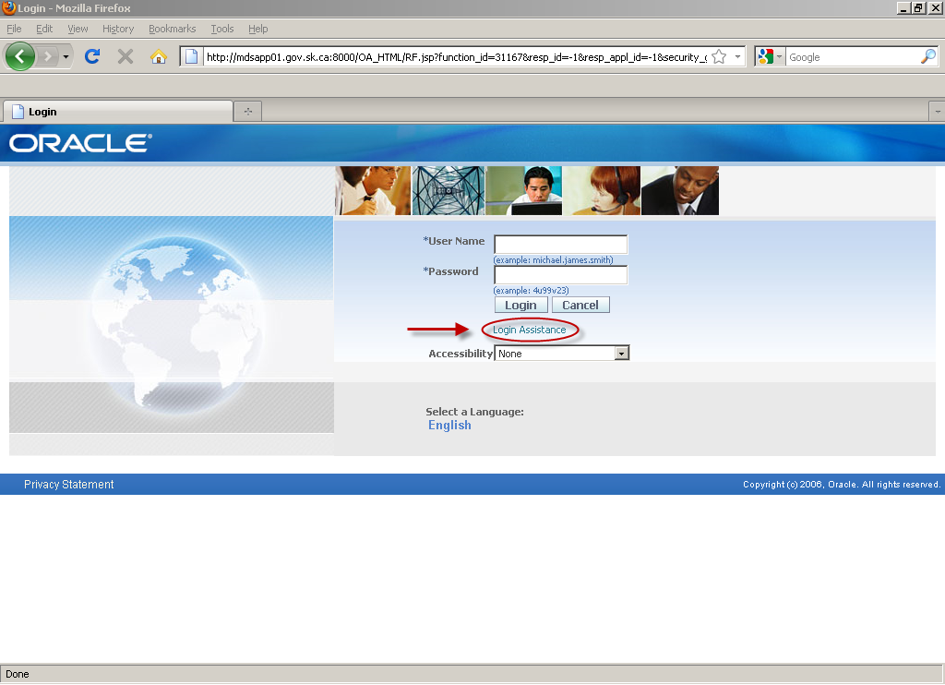

Enter user name in the “Forgot Password” section and click the “Forgot Password” button.

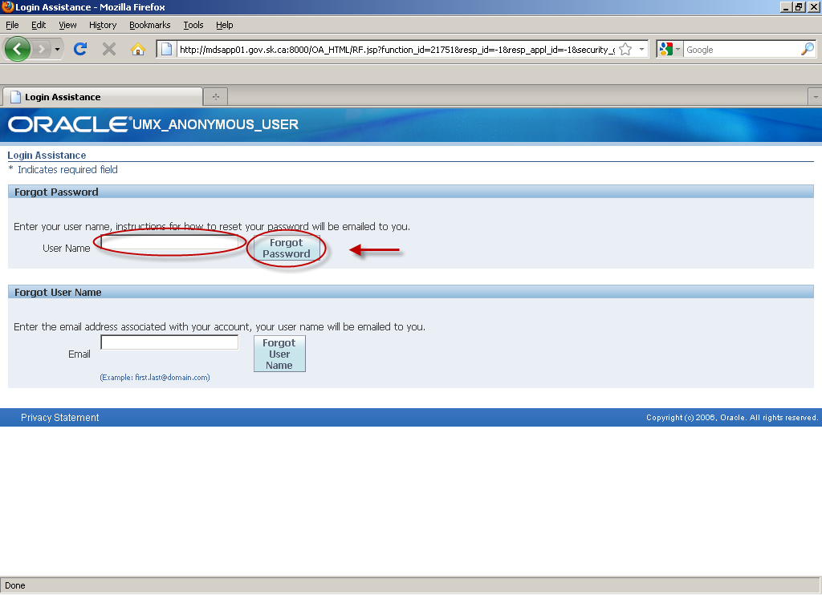

The following message will appear. Click “Ok”.

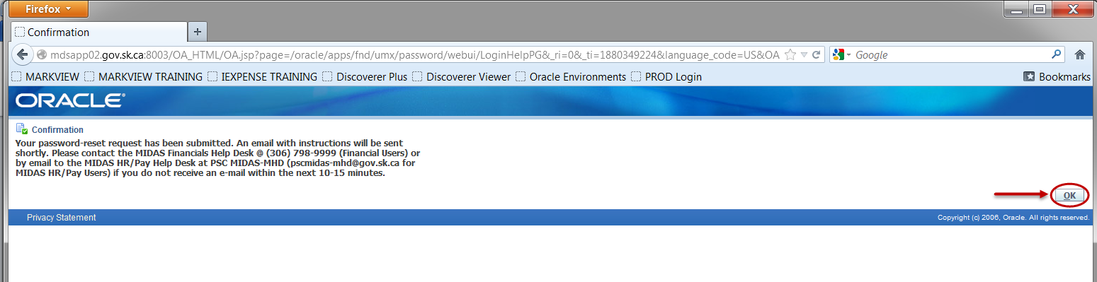

If you do not receive an email within 10-15 minutes contact the appropriate help desk as per the above message.

In the email that is received click “Reset your password”.

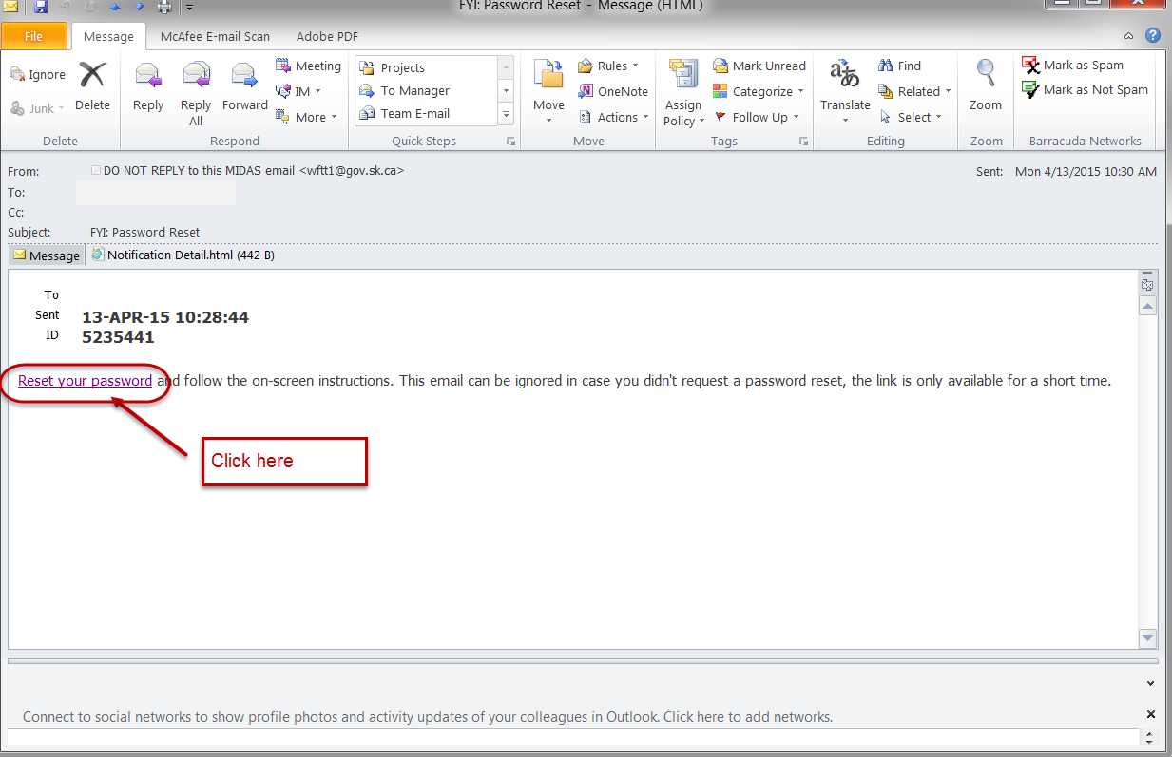

Enter username and a new password and click “Confirm Password”.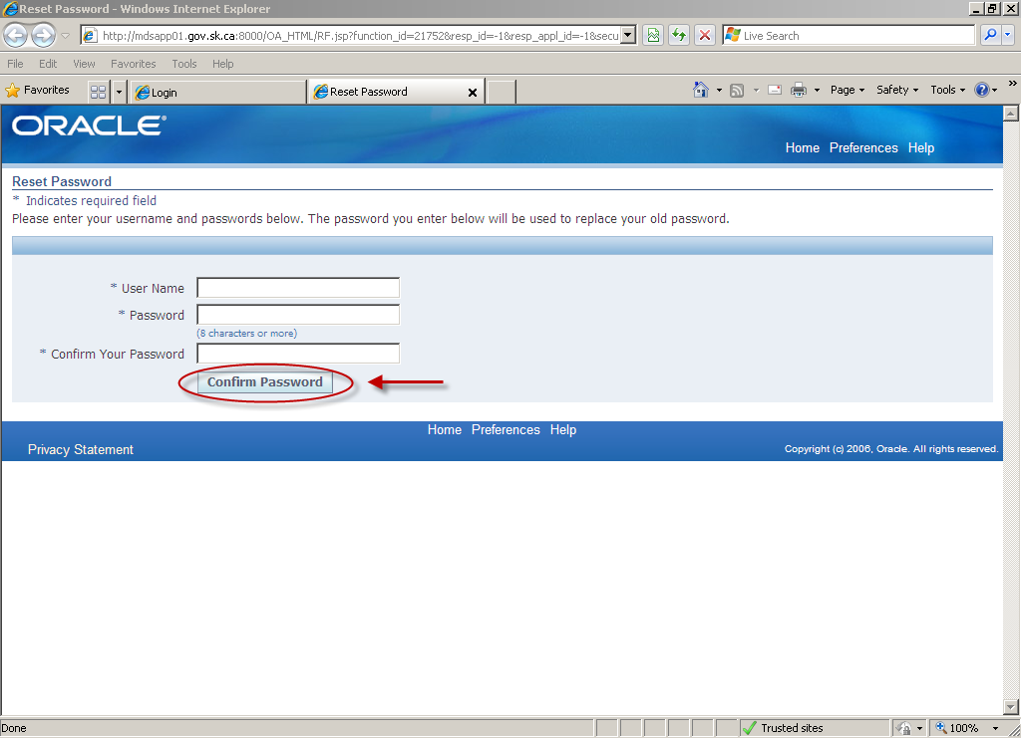

Click “Ok” to be returned to the Login Page**.**

**Note** that users that access MIDAS with a desktop MIDAS Firefox icon will need to exit from this screen and log in with their new password using their desktop MIDAS Firefox icon.

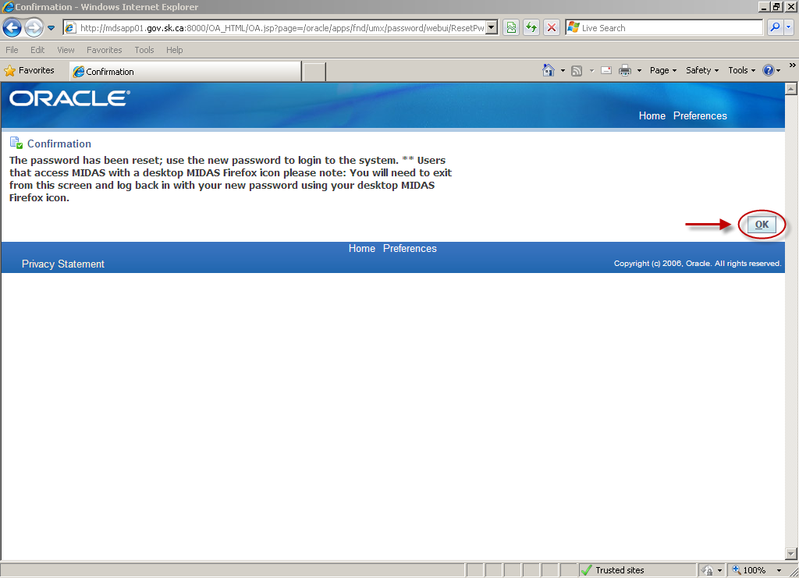

**2. Instructions to recover your user name**

On the Login Page click on “Login Assistance”.



Enter your email address in the”Forgot User Name” section and click the “Forgot User Name” button.

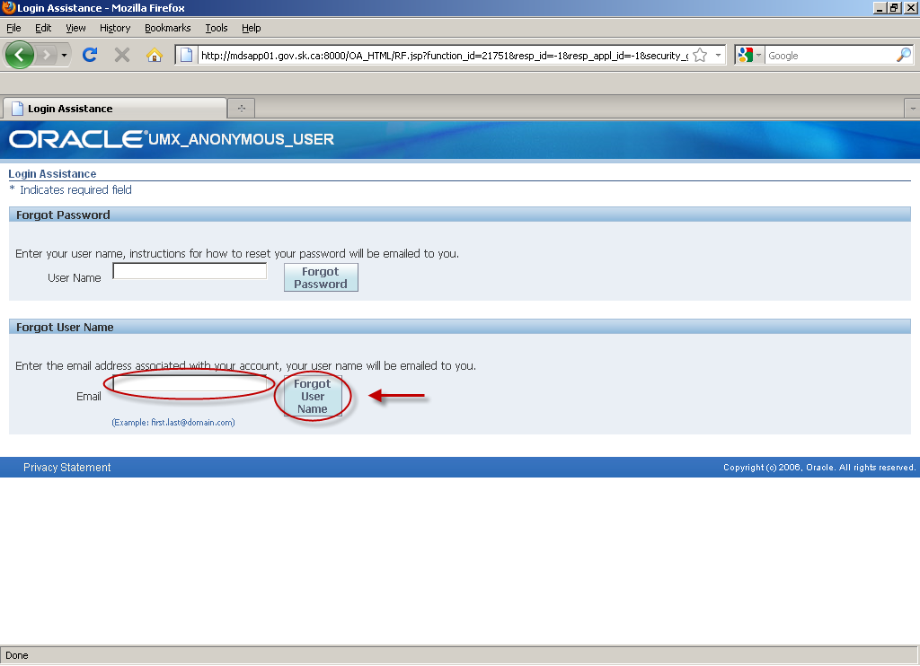

The following message will appear. Click “Ok”.

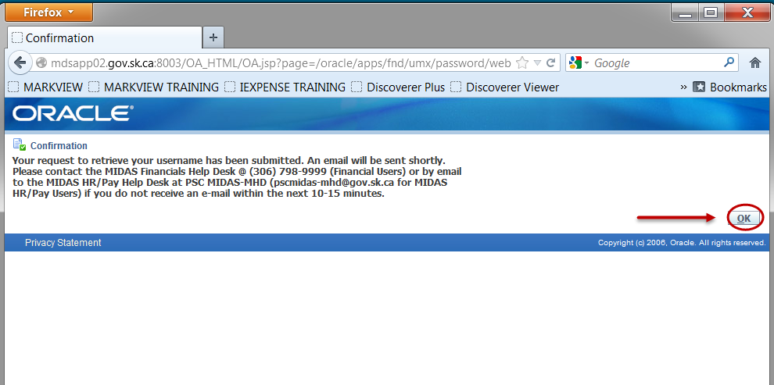

If you do not receive an email within 10-15 minutes contact the appropriate help desk as per the above message.

An email will be sent to you showing the username associated with the email address. Clicking on the “login” link will open the Login Page. Clicking on the “reset your password” link will open the “Reset Password” page if you also need to reset your password.

**Note** that users that access MIDAS with a desktop MIDAS Firefox icon will need to log in using their desktop MIDAS Firefox icon and not the link provided in this email.

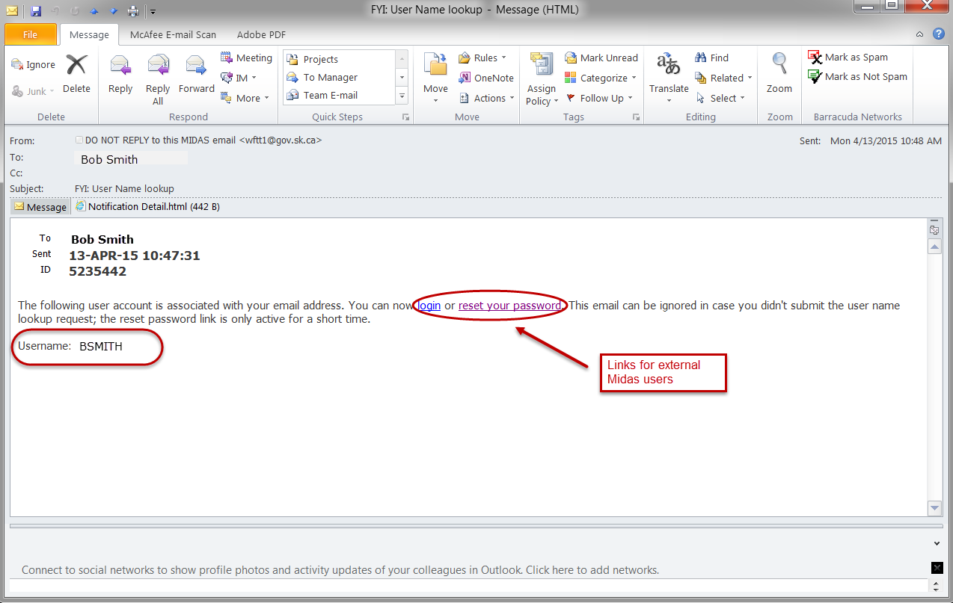

Please contact one of the MIDAS Help Desks if you have any questions or problems with these processes.

**MIDAS Financials Help Desk**

**Ministry of Finance**

**Phone: (306) 798-9999**

**Email: FI GRP - MHD (finmhd@gov.sk.ca)**

**MIDAS HR/PAY Help Desk**

**Public Service Commission**

**Email: PSC MIDAS-MHD (PSCMIDAS-MHD@gov.sk.ca)**